Calculate Trip Cost

|  |  |  |  |
| --- | --- | --- | --- |
|  | Prepared By | Reviewed By | Approved By |
| Name | M Shashidhar | Venkataraman |  |
| Role | Intern | Batch Trainer |  |

Table of Contents

1. Introduction…………………………………………………………………..…3

               1.1 Intended Audience……………………………………………….......3

               1.2 Project Scope…………………………...……………………………3

2. Overall Description…………………………………………….……………….4

               2.1 Operating Environment……………………...……………………....4

3. Requirements……………………………………………………………...…….4

              3.1 Functional Requirements……………………....…………………….4

               3.1.1 Search Hotels ………………………………………………...4

              3.1.2 Find Hotels….…….………………………………...………...5

  3.1.3 Inclusion points …………………………………..…………...6

3.1.4 Invalid Details ………………………………………………..8

**1. Introduction**

Yatra.com is a comprehensive travel platform that caters to both leisure and business travelers. It offers a wide range of hotels across Indian cities, catering to both leisure and business travelers. You can choose from various categories, including budget, mid-range, and five-star hotels.

Yatra offers a convenient platform for booking cruises. Whether you’re dreaming of a Mediterranean voyage or an adventure on a Star Cruise, you can find the best deals and offers on Yatra.com

Yatra’s gift cards are perfect for sharing memories with your loved ones.

**1.1 Intended Audience**

Business Unit (BU) SME

Academy coach

Technical Trainer

**1.2 Project Scope**

This document defines at a functional level the business activities that are encompassed by the system and the rules that apply to them. It also encompasses some of the key high and low level technical requirements of the system.

It draws heavily on both proposed Framework and Business Rules and the Technical Architecture documents. The scope of the detailed analysis project phase specifies that this document will include.

· Classification of requirements according to their functional areas.

· A description of each process in the system, including their inputs, outputs, and data transformation rules.

**2. Overall Description**

**2.1 Operating Environment**

Windows operating system

Web application

**3. Requirements**

This part of the requirement document serves to search for first three Hotel names in desired location and also we need to select one cruise line and retrieve all the Inclusion points and check whether it captures error message or not after entering invalid data in gift voucher.

**3.1 Functional Requirements**

**3.1.1 Req0001**

**Req0001a-** click on hotels button and set the location.

**Req0001b**- select the checkin and checkout dates.

**Req0001c-** set the traveller count.

**Req0001d**- click on search hotels button.

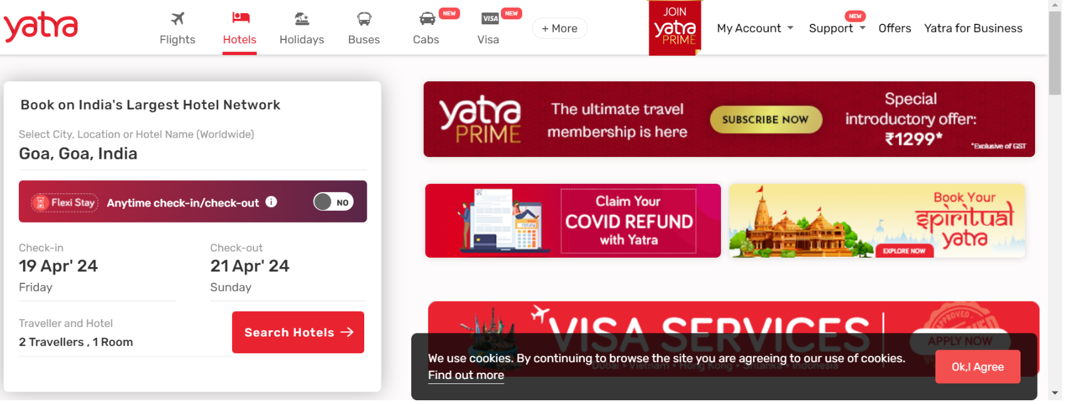

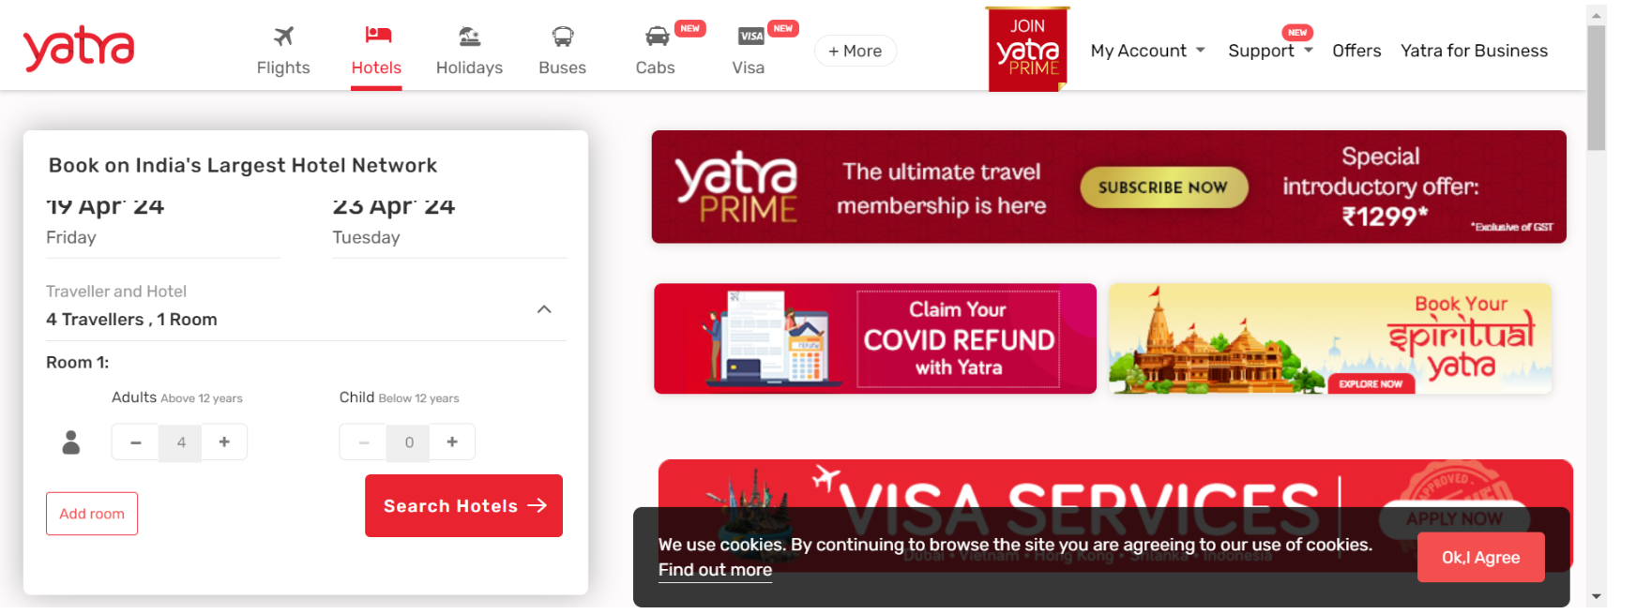

**3.1.2 Req0002**

**Req0002a**- sort the list with highest user rating.

**Req0002b**- select free wifi and free breakfast filters and also select laundry and swimming pool filters under amenities

**Req0002c**- collect the hotel details.

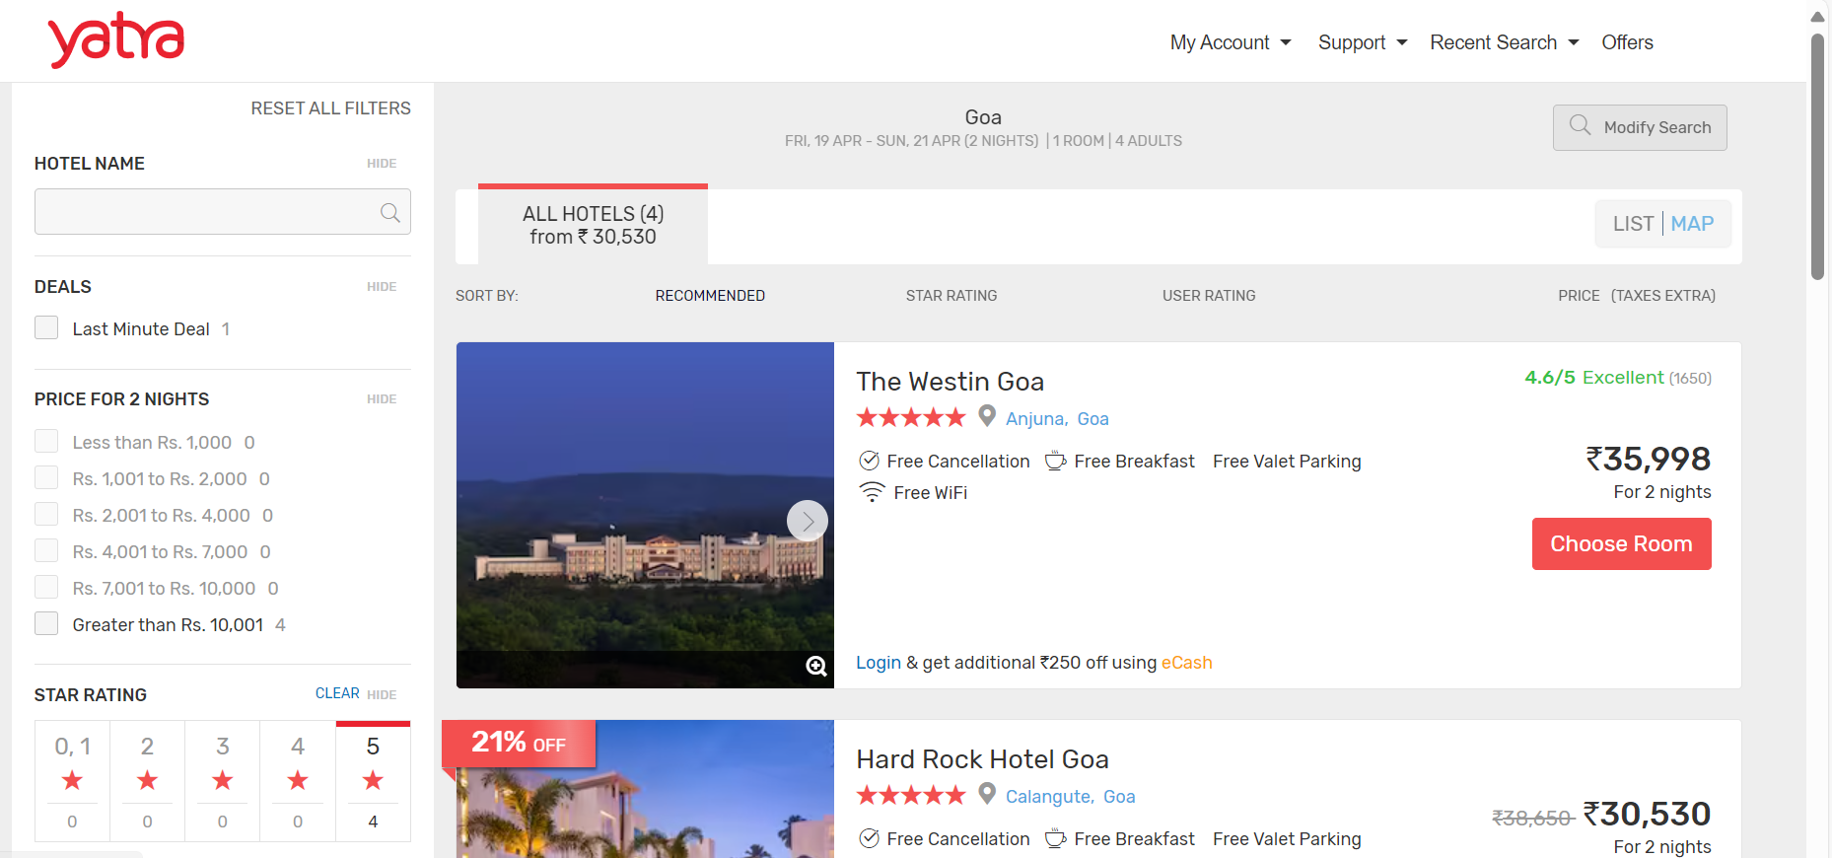

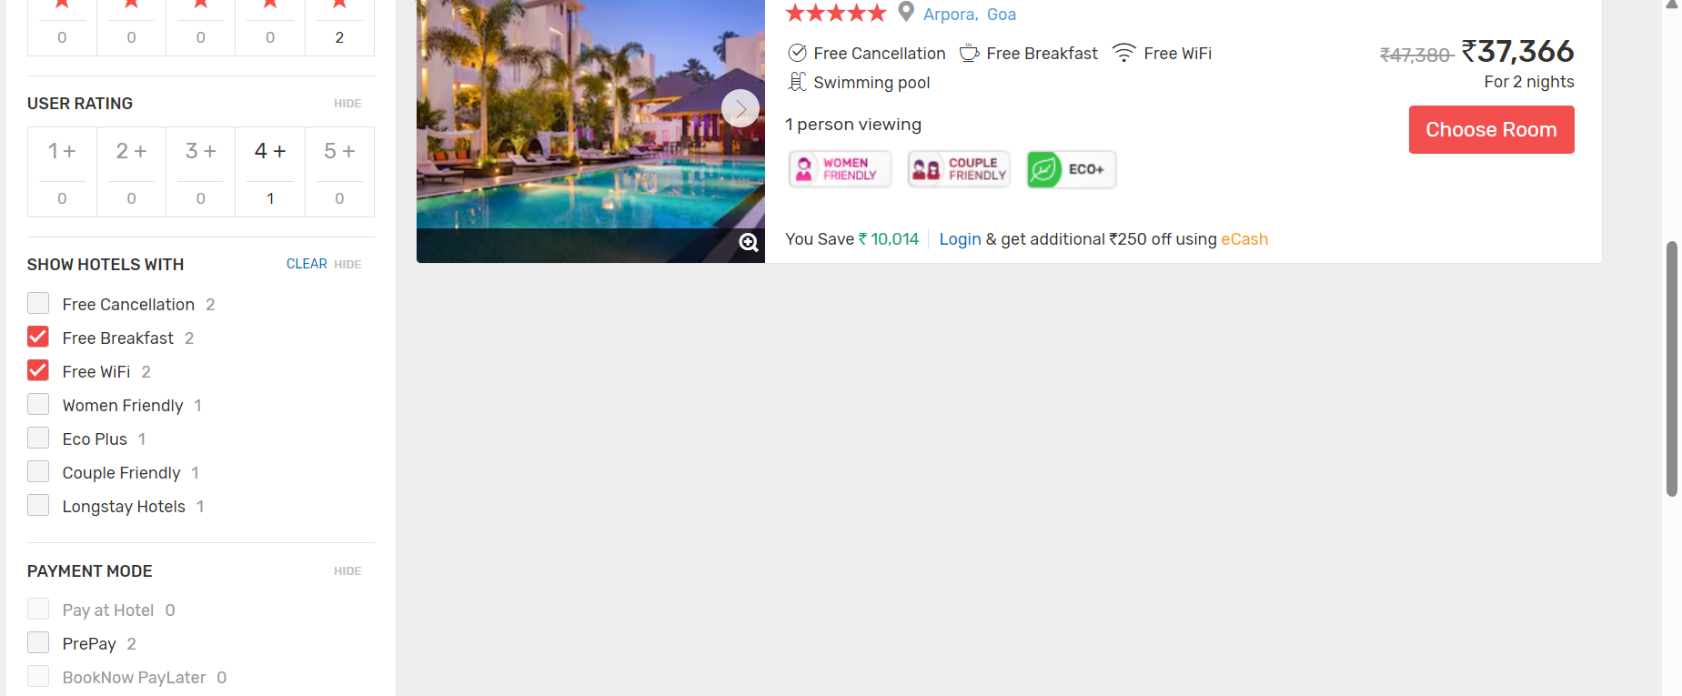

**3.1.3 Req0003**

**Req0003a-** click on cruise and select first cruise line.

**Req0003b**- capture the inclusion points.

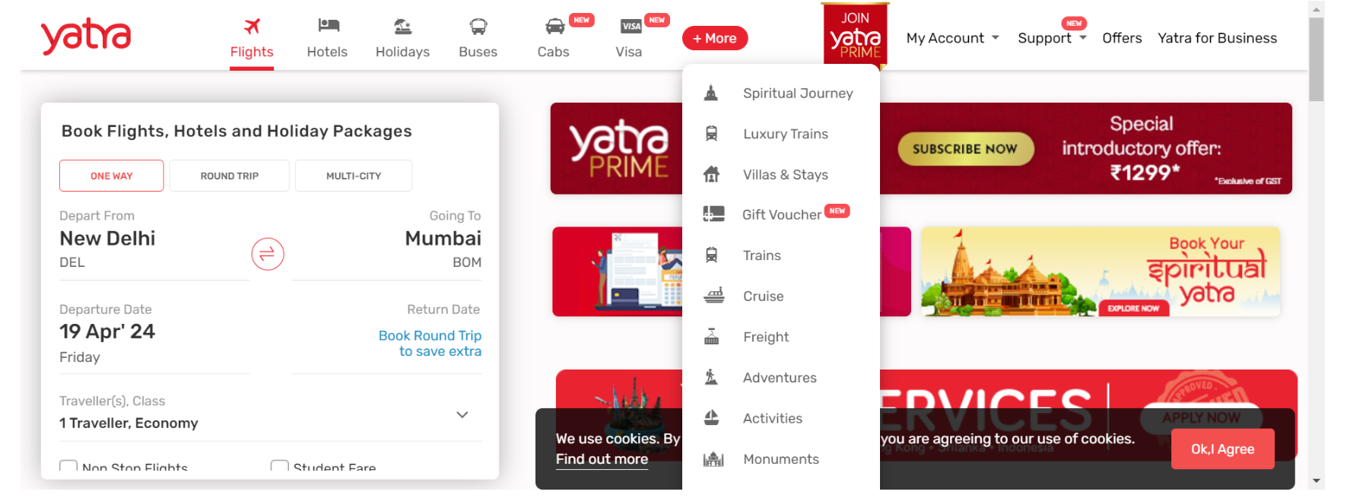

**3.1.4 Req0004**

**Req0004a-** The user clicks on gift voucher page.

**Req0004b**- User give invalid details.

**Req0005c-** Capture the error message.

